Australasian Neuromuscular Network Inc.
Annual General Meeting Minutes
Date: | 26th March 2025
Time: | 4:30pm
Place: | Sunshine Coast Convention Centre, Queensland

Attendees: | Justine Adams, David Belowitz, Anita Cairns, Kate Carroll, Andrew Clarke, Joshua Clayton, Katy de Valle, Robin Forbes, Emily Girvan, Peter Houweling, Kathryn Irving, Rachel Kennedy, Leonit Kiriaev, Sharon Kwiatkowski, Nigel Laing, Sharon Leaver, Christina Liang, Michelle Liddicut, Chia-Yi Lin, Michelle Lorentzos, Suzanna MacLennan, Sarah Mollet, Katrina Morris, Gina O’Grady, Anna O’Malley, Chien Yen Poh, Gina Ravenscroft, Miriam Rodrigues, Avnika Ruparelia, Emma Rybalka, Daniel Schweitzer, Nicole Shears, Nicole Thomas, Cara Timpani, Catherine Watts, Ian Woodcock, Dennis Yeow, Eppie Yiu, Laura Issa, Kristy Rose, Angus Lindsay, Emily Oates
Apologies:

Item | Description
1 | Acknowledgement of Country
2 | Minutes from 2024  Minutes were sent to members by email and uploaded to the ANN.org.au website on Monday 24th February 2025.  Resolution 1: Proposal to accept minutes as an accurate reflection of the annual general meeting in 2024.  Proposed: Ian Woodcock  Seconded: Anita Cairns  Voted: (show of hands) – passed
3 | Treasurer’s report including financial statement for financial year ending 31 January 2025 (presented by Eppie Yiu, treasurer)  Treasurer activities  Submit quarterly BAS reports  Receive and manage ATO correspondence  Work with bookkeeper – Convention Associates  Consult with accountant – Maximise business consulting  Manage ANN Inc bank accounts  Manage membership payment platform – Stripe  Manage membership with bookkeeper  Issue invoices, arrange payments to vendors  Liaise with website design company - Vesanique  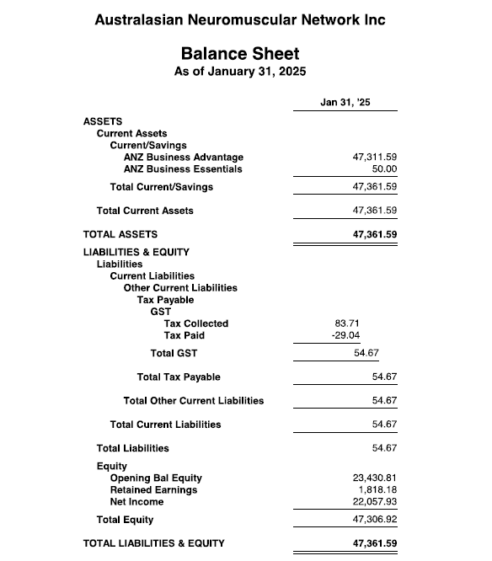  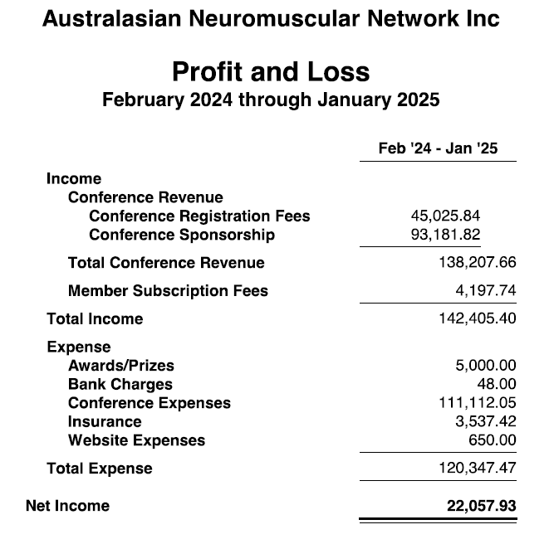  Questions and/or comments invited from the membership – none offered  Motion 2:  Proposal to accept the financial statements of ANN Inc. for the financial year ending March 2025 as reported at the AGM 26th March 2025  Proposed by: Eppie Yiu  Seconded by: Anita Cairns  Voted: (show of hands) – passed
4 | Voting on Resolutions and Special Resolutions  Special resolution: Motion 3  Proposal to change the financial year for ANN  From: 1st February to 31st January  To: 1st January to 31st December  Aligns with BAS quarters – easier reconciliation and BAS reporting  Note: Charities are exempt from requiring approval for a substituted accounting period (SAP)  Special Resolution: Resolution 3: Proposal to change the financial year for ANN Inc. to January to December  Proposed: Ian Woodcock  Seconded: Katrina Morris  Voted: by PollEverywhere passed 97% yes; 3% No (37 responses)  Resolution 4: Proposal to change the constitution of the ANN Inc. to allow the AGM to occur 6 months after the AGM  Wording change to: Proposal to change the constitution of the ANN Inc. to allow the AGM to occur within 6 months after the end of the financial year  Proposed: Eppie Yiu  Seconded: Katrina Morris  Voted: by PollEverywhere passed 100% yes 0% no (40 responses)  Special Resolution: Resolution 5: Proposal to change the ANN Inc. to become a charity registered with the ACNC  Proposed: Eppie Yiu  Seconded: Anita Cairns  Voted: by PollEverywhere passed 100% yes 0% no (38 responses)  Resolution 6: Vote to change the way memberships are paid: from 2026 membership for 12 months will be included in the cost of the congress attendance ticket, rather than a separate cost. Those not attending the congress can still join/renew membership through the ANN website.  Information presented:  104 paid up members currently  Proposed: Eppie Yiu  Seconded: Suzanna MacLennan  Voted: by PollEverywhere passed 100% yes 0% no (39 responses)  Resolution 7: Vote to create an ANN authorship group  Information presented:  ANN as a writing group - Will elevated ANN’s international profile  SMA Care Guidelines as a test case  Plan is:  - Volunteers to be in working groups, focusing on specific care areas  - Working groups research area and provide a summary and recommendation to feedback to group as a whole at a face-to-face consensus meeting  - Whole writing group meeting three times (on-line) to develop the guidelines, with final, sign off meeting face to face at ANN 2026  - Supported by medical writer – cost $80k-$180K  - Funded by educational grants from Pharmaceutical companies (hopefully matching amount from all three)  - Manuscript written by three fellows/ECRs with three senior authors and others listed in the “ANN Working Group”  Extensive discussion, clarified that the Care Guidelines would be Australia and NZ focused, needs to involve Patient and Family Groups, there is a similar MND care guidelines project starting, would need a formal EOI process for ECRs involved. Concerns raised about amount of work required, how much would be done by a medical writer. Wording questioned – suggested Vote to support the idea of an ANN authorship group and or the ANN hold workshops; suggestions to do Australasian SMA care guidelines with an ANN authorship group as a test case.  Resolution 7 - not voted on  Resolution 8: Vote to start the process of formalizing network agreements between collaborating institutions. Can we use some of the funds to pay for legal support to start this process?  Information presented:  Difficulty in collaborating  Legal blocks  Proposal: To formalise the Australasian Neuromuscular Network and get our institutes to enter into a Research Network Consortium Agreement  Will set up terms of references and start to iron out some of the legal issues that come up every time we need to sign an MTA.  There may be some legal expenses setting this up.  Discussed, suggestion to start with getting some legal advice on the value and any risks for the ANN in doing this; another suggestion to speak to Paula Bray  Based on the discussion points, additional question asked of the membership present:  Who thinks we should consider formalizing network agreements between collaborating institutions?  Proposed: Ian Woodcock  Seconded: Anita Cairns  Voted (show of hands): passed  Can we use some of the funds to pay for legal support to get advice about this process?  Proposed: Ian Woodcock  Seconded: Anita Cairns  Voted: by PollEverywhere passed 100% yes 0% no (33 responses)  Resolution 9: ANN on social media – propose changing social media platform from Twitter/X to BlueSky and LinkedIn  Proposed: Ian Woodcock  Seconded: Katy de Valle  Voted: show of hands – passed  Resolution 10: Proposal for regular ANN achievements newsletter?  Discussion about making it more about comms in general; pros and cons of email newsletter vs posting on social media  Wording change: Proposal to pay someone for half a day per month to compile regular ANN achievements for newsletter  Proposed: Ian Woodcock  Seconded: Anita Cairns  Voted: by PollEverywhere passed 100% yes 0% no (32 responses)
5 | Any other business  Mailchimp problems – acknowledged, Ian will work on a better email system that doesn’t go to spam/junk  Place on website for grant/funding information  ANN Congress 2026 – co-badged with Asian Oceania Myology Center 3-5 June 2026 in Perth. Organising committee being chaired by Gina Ravenscroft – she will be inviting people to join  ANN 2027 – needs to be planned well ahead;
6 | Future Congress plans  2026 – co-badged with Asian Oceania Myology Center 3-5 June 2026 in Perth. Organising committee being chaired by Gina Ravenscroft – she will be inviting people to join  ANN 2027 – needs to be planned well ahead; likely back on the Sunshine Coast, support in the room for using the same venue as 2025
7 | Meeting close

Minute taker: | Kate Carroll (ANN secretary)

Signed: | 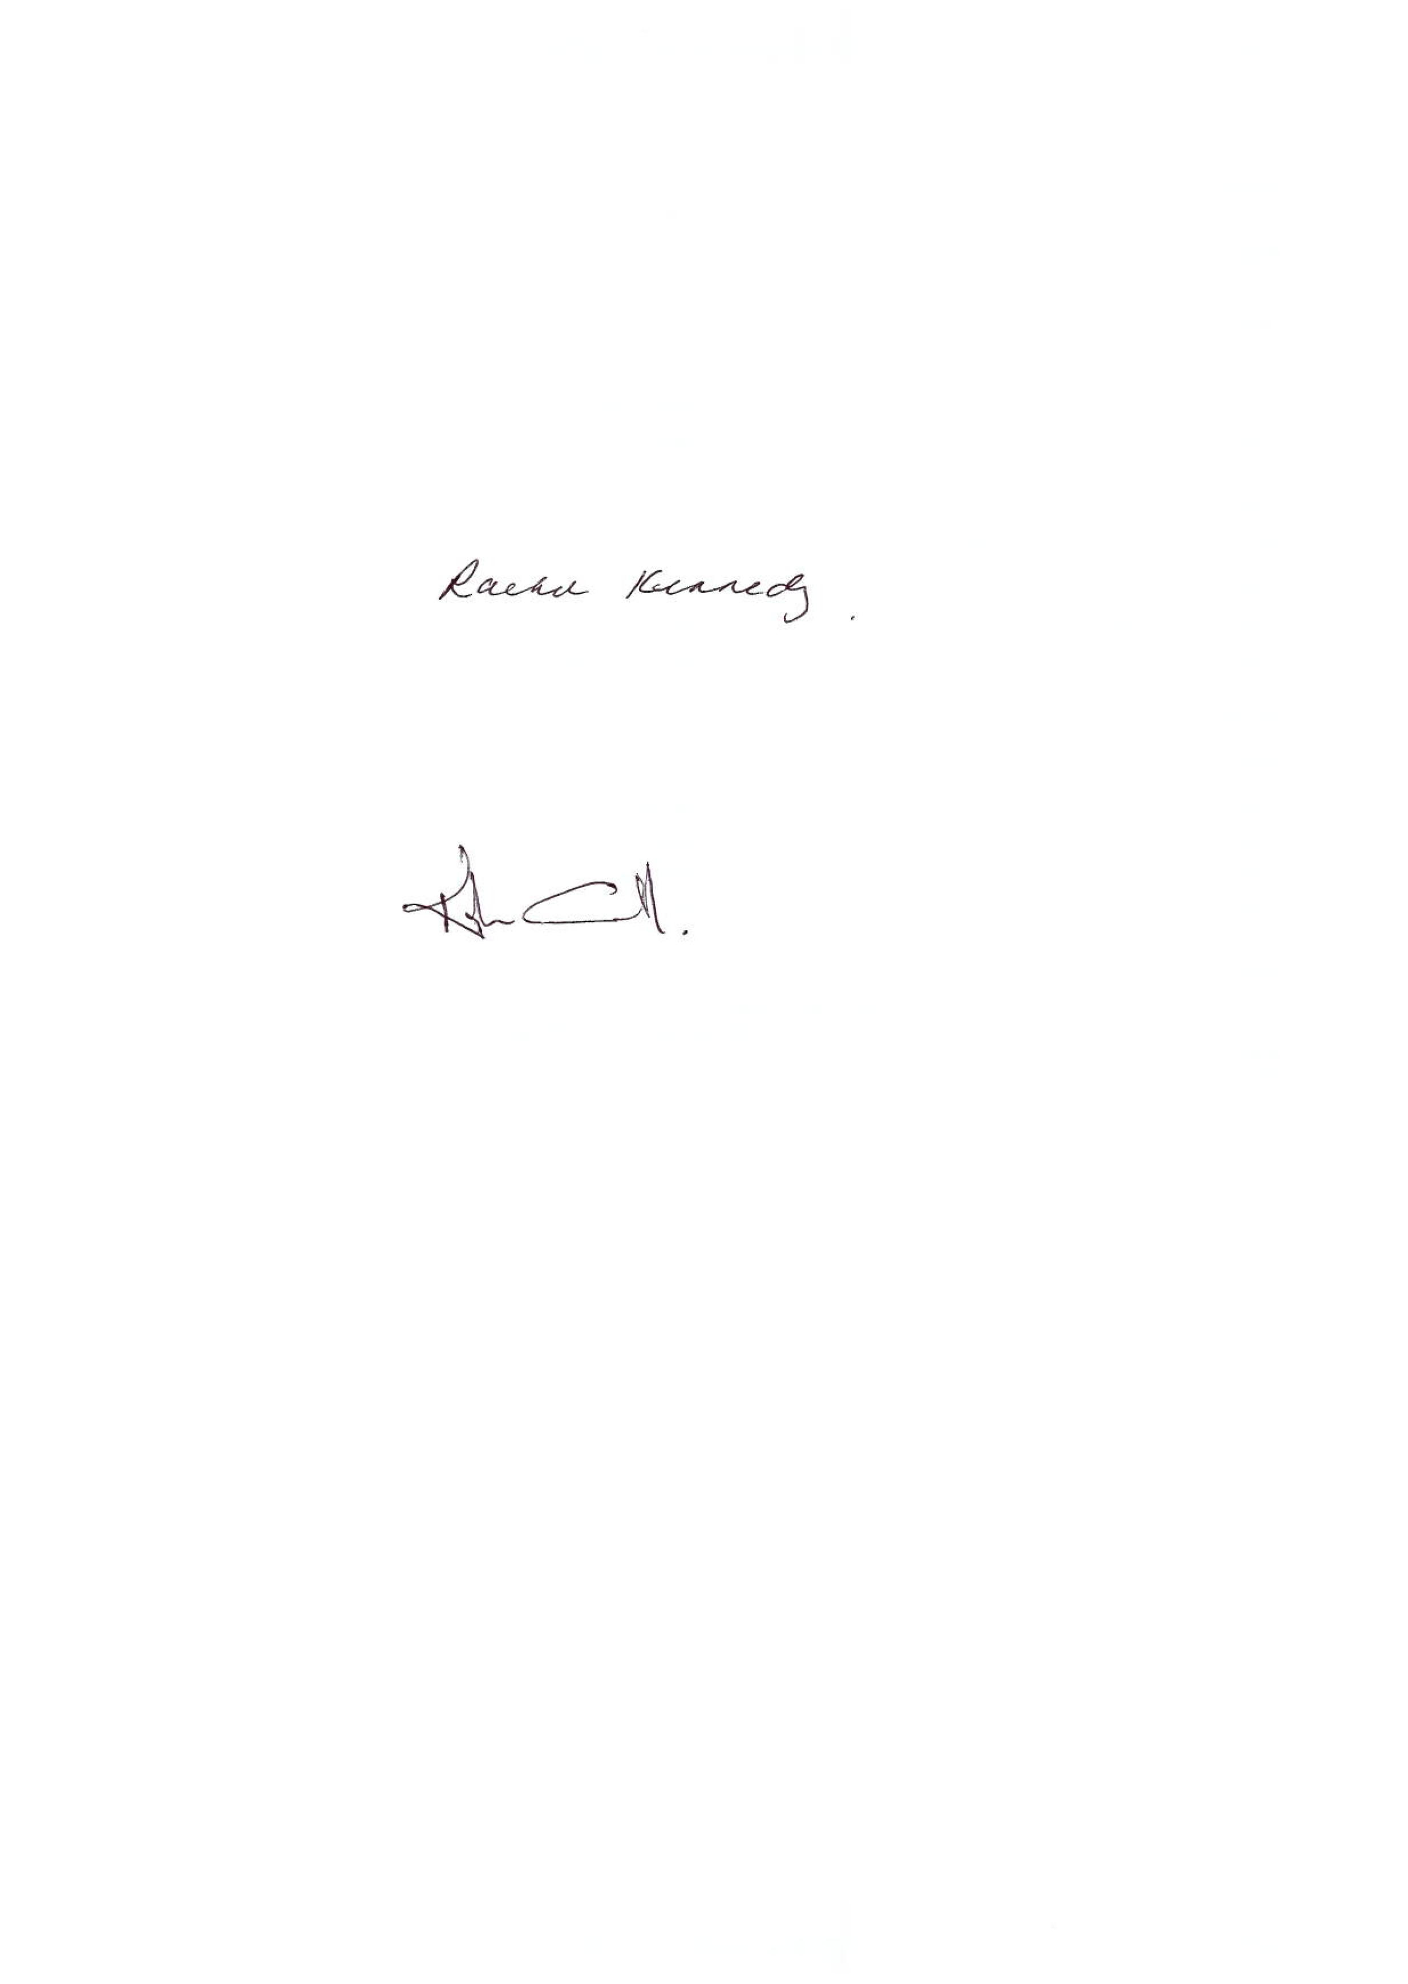
Name: | Kate Carroll
Date: | 26/05/2025

